**Section - b : 25 Marks**

**Instructions :**

1. **This section is openbook**
2. **Write the answer next to the question in this word document.**
3. **Submit this word document and the R file in a zip folder**

Attribute Information:

Input variables:

# bank client data:

1 - age (numeric)

2 - job : type of job (categorical: 'admin.','blue-collar','entrepreneur','housemaid','management','retired','self-employed','services','student','technician','unemployed','unknown')

3 - marital : marital status (categorical: 'divorced','married','single','unknown'; note: 'divorced' means divorced or widowed)

4 - education (categorical: 'basic.4y','basic.6y','basic.9y','high.school','illiterate','professional.course','university.degree','unknown')

5 - default: has credit in default? (categorical: 'no','yes','unknown')

6 - housing: has housing loan? (categorical: 'no','yes','unknown')

7 - loan: has personal loan? (categorical: 'no','yes','unknown')

# related with the last contact of the current campaign:

8 - contact: contact communication type (categorical: 'cellular','telephone')

9 - month: last contact month of year (categorical: 'jan', 'feb', 'mar', ..., 'nov', 'dec')

10 - day_of_week: last contact day of the week (categorical: 'mon','tue','wed','thu','fri')

11 - duration: last contact duration, in seconds (numeric). Important note: this attribute highly affects the output target (e.g., if duration=0 then y='no'). Yet, the duration is not known before a call is performed. Also, after the end of the call y is obviously known. Thus, this input should only be included for benchmark purposes and should be discarded if the intention is to have a realistic predictive model.

# other attributes:

12 - campaign: number of contacts performed during this campaign and for this client (numeric, includes last contact)

13 - pdays: number of days that passed by after the client was last contacted from a previous campaign (numeric; 999 means client was not previously contacted)

14 - previous: number of contacts performed before this campaign and for this client (numeric)

Output variable (desired target):

15 - y - has the client subscribed a term deposit? (binary: 'yes','no')

**Logistic Regression and Trees (Classification Problems) : 6 Marks**

**Q1. Answer the following questions from the dataset “bank-full.csv”**

Read the dataset and split into test and training sets and before splitting set the seed to 1000 and 60% should go into training set.

1. Build a logistic regression model(model1) for predicting “y” with the help of the variables “age”, “balance”, ”campaign” and “duration”. Build another regression model (model2) with above mentioned attributes excluding “campaign”. Specify the AIC value in both the models and mention which is the best model among both.

**Answer :**

The value of AIC in **model1** is **16262** and the value of AIC in **model2** is **16407**. The model1 is preferable because of **lower AIC value** when compared with model2.

2. Compute the values of Sensitivity, Specificity for above model (with campaign).

**Answer :**

The sensitivity of the model1 is **0.01924353**.

The specificity of the model1 is **0.8701983**.

3. Make predictions on the test set and Compute the AUC of the “model1”

**Answer :**

The value of **AUC** is **0.8179142**.

4. Build a CART model for predicting “y” with the help of the variables “age”, “balance” and “duration”. Plot it and mention the number of splits you see in the plot.

**Answer :**

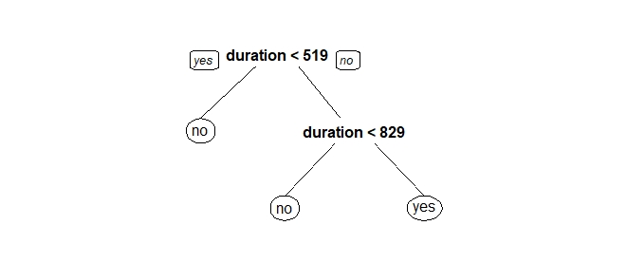

The number of splits in the plot are **2**.

**5.** Make predictions on test data using the model created in above Problem 2 and compute the value of AUC.

**Answer :**

The value of AUC in case of **model2** is **0.8097155**.

6. What proportion of the customers are “Married” and have “technician” job.

**Answer :**

**Text Analytics and Clustering**

**Q2. Answer the below questions from the dataset “Movies.txt”**

Load the data into R and assign the following variables as the column names in the same order.

"ID","Title","ReleaseDate","VideoReleaseDate","IMDB","Unknown","Action","Adventure","Animation","Childrens","Comedy","Crime","Documentary","Drama","Fantasy","FilmNoir","Horror","Musical","Mystery","Romance","SciFi","Thriller","War","Western"

1) Eliminate the first four variables from the dataframe. What is the number of movies which belong to both “action” and “horror” category. **1Mark**

**Answer :**

There are **13** movies that belong to both “Action” and “Horror” Genre.

2) Build a hierarchical clustering model with the Euclidean distances. Plot the dendogram. What is the number of clusters at a height of 150.  **1Mark**

**Answer :**

There are approximately **7 clusters** at a height of 150.

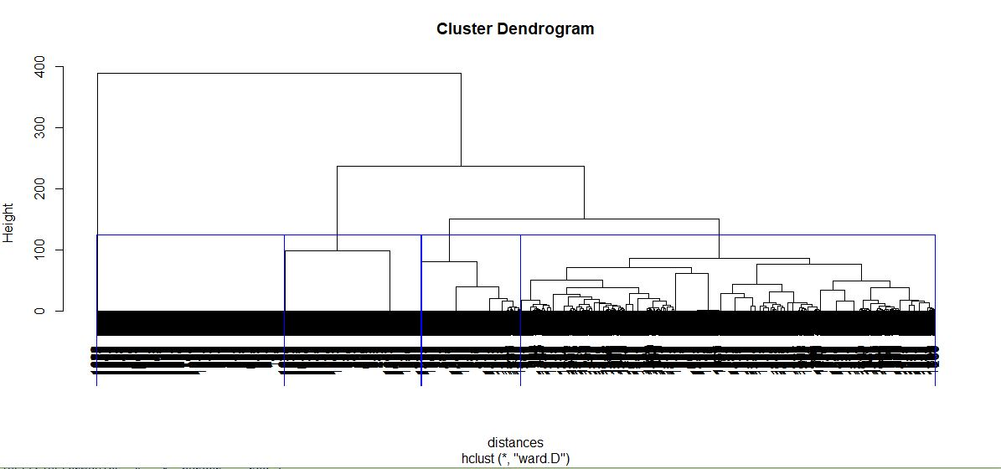

3) Split the above model into 7 clusters. What are the clusters with maximum and minimum number of observations.  **1Mark**

**Answer :**

The cluster with **minimum number** of observations is **Cluster 7** and the cluster with the maximum number of observations is **Cluster 2**.

4) What is the number of Adventure category movies in Cluster 1 of the above model.  **1Mark**

**Answer :**

There are **56 movies** that belong to Cluster 1 which is of **Adventure Genre**.

5) Which is the cluster with highest number of movies belonging to “Children” category.  **1Mark**

**Answer :**

Cluster 1 has the highest number of movies that belong to **“Children”** category with **118 movies**.

6) Which is/are the clusters with least number of movies belonging to “Fantasy” category. **1Mark**

**Answer :**

All the clusters except **Cluster 1** have the least number of movies in the **Fantasy** category.

7) Build a K-means clustering model with seed value 1000 and same number of clusters. Mention the clusters which have the highest and least number of observations.

**0.5Mark**

**Answer :**

The cluster having **highest** number of observations is **Cluster 3** and the cluster having lowest number of observations is **Cluster 4**.

8) Which Hierarchical Cluster best corresponds to K-Means Cluster 6? **0.5**

**Answer :**

K - Means Cluster 6 closely corresponds to **Hierarchical Cluster 2**.

9) Which Hierarchical Cluster best corresponds to K-Means Cluster 4? **0.5**

**Answer :**

K - Means Cluster 4 corresponds to **Hierarchical Cluster 1**.

10) Which Hierarchical Cluster best corresponds to K-Means Cluster 3? **0.5**

**Answer :**

We cannot categorize it because the **percentage < 50%**.

11) Which K-means cluster has got more number of movies belonging to “Action” genre.**0.5**

**Answer :**

The K - Means cluster with most number of movies in the “Action” genre is **Cluster 6**.

12) Which K-means cluster has got more number of movies belonging to “War” genre. **0.5**

**Answer :**

The K- Means cluster with more movies belonging to “War” genre is **Cluster 4**.

**Text Analytics : 5 Marks**

**Q3.** **Answer the below questions using the dataset “energy_readings.csv”**

1) What is the number of observations in the dataset. What is the proportion of emails that are responsive in the dataset.

**Answer :**

There are **855** observations in the dataset.

2) Convert all alphabets into lowercase, remove punctuations, eliminate stop words and go for stemDocument and also remove sparse terms.

Build a CART model(classification) with seed value 1500 and train the model with 75% of the observations and plot the model.

3) Make predictions on the test set and mention the proportions of responses with value more than (i)0.5 (ii)0.7 (iii)0.9

**Answer :**

(i) The proportion of responses with value more than **0.5** is **0.07476636**.

(ii) The proportion of responses with value more than **0.7** is **0.07476636**.

(iii) The proportion of responses with value more than **0.9** is **0.1635514**.

4) What is the accuracy of the model with predicted response of the test set (i)>0.6 (ii)0.8

**Answer :**

(i) The accuracy of the model with predicted response of the test set **> 0.6** is **0.8878505**.

(ii) The accuracy of the model with predicted response of the test set **> 0.8** is **0.8878505**.

5) Plot the ROC curve for the model and computer the value of AUC.

**Answer :**

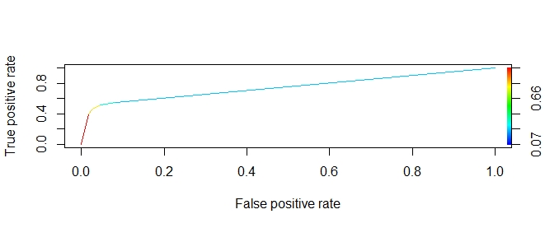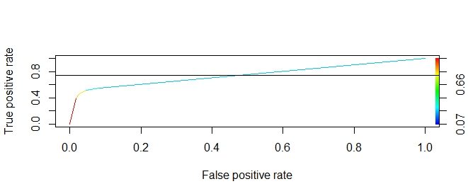

The value of **AUC (Area under the ROC Curve)** is **0.743735**.

**Visualization : 5Marks**

**Q4. Answer the following questions from climate_change.csv dataset**

1) Load the data into R and find out the number of observations and the number of unique years.

**Answer :**

The number of observations are **308** and there are **26** unique years in the data set.

2) Plot the variables “N2O” and “Temp” on X and Y axes respectively and make it a line plot. Name the axes as “Concentration of N2O” and “Temperature” respectively.

**Image :**

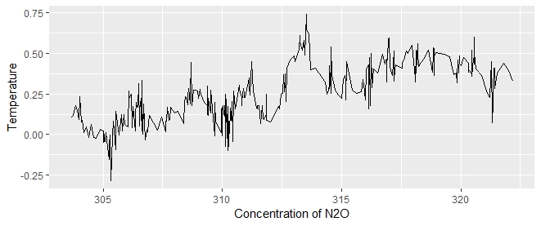

3) Build a linear regression model to predict “Temp” over “Aerosols” and plot the linear equation using ggplot2.(Go for a line graph) Also plot the regression line.

**Image:**

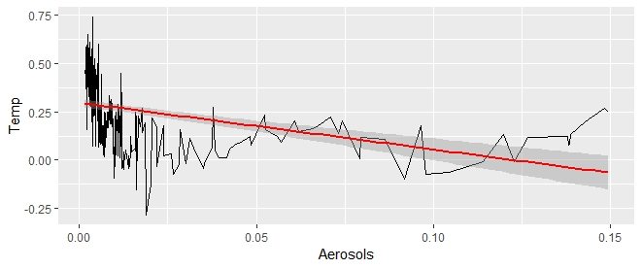

**Answer the following questions from “intl.csv”**

4) Plot the bar chart with region on X-axis and Percentage of International students on Y axis. Keep the stat as “identity” and fill in the bars with red color and add label “International Students Percentage” on y axis and the element text angle of 90 and horizontal justification of 1.

**Image:**

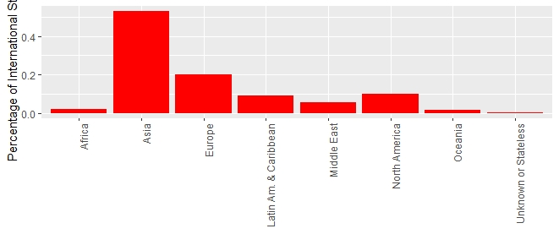

5) Plot the pie chart with the regions as the labels.

**Image:**

